**THIS IS IN DRAFT FORM**

**Table of Contents**

**How the 3D Printer Works.**

We use a Dimension SST 1200es, manufactured by Stratasys. It is a Fused-Deposition Modeling system, and this is how it works:

After a 3D model has been designed and exported, a special program slices it up into cross-sections .01" thick. It looks at each cross-section and generates a set of instructions on how to build it. When this information is sent to the printer, it starts with the bottom-most layer, laying down plastic in the shape of the cross-section. When it finishes the first layer, it moves up .01" to start on the next layer. Take a close look at a 3D-printed model and you'll notice that it is actually stepped.

The machine consists of a moving bed (Z-axis) and a print head (X-axis and Y-axis). The print head has a heating element in it; thermoplastic is forced into the print head, melts, and is squeezed out, not unlike toothpaste. The print head is calibrated in such a way that the molten plastic coming out of it is always .01" thick.

In order to form complex shapes, overhangs, and hinges/joints/free-moving objects, the plastic needs to be held up by something. The machine prints using a second material, which we call the 'support.' When the print is done, it is put in a bath of solution that dissolves away the support material, leaving only the finished model.

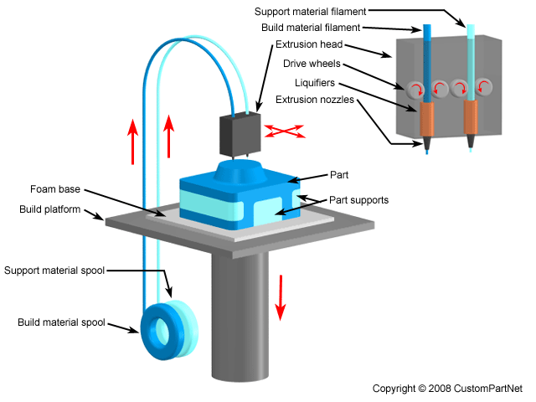

**Working with Tolerance and Support Material.**

There are a few basic guidelines to follow when developing a model for printing. These won't help you *edit* a model; these are things to keep in mind when designing it.

**Wall Thickness** - The printer can print walls as thin as ~0.01", however these will not be structurally sound. Keep walls to a minimum of 0.04" for rigid structure.

**Suspended Parts** - It is possible to make joints by leaving some space between two interlocking parts; leave at least 0.02" or the printer may connect the two parts. If a part is threaded or must fit snugly, it is best to print it separately (when possible).

This is an open list; if you'd like to add something, please e-mail iduarts.techroom@gmail.com.

technical info

If your model is highly detailed and or a complex shape, consult a tech before submitting.

* * * * *

Model Interior settings:

Solid: fills any interior space with 100% plastic. Strongest and most expensive option.

Sparse High Density: fills interior space with a grid pattern. Very strong and cheaper than Solid fill.

Sparse Low Density: fills interior space with a grid pattern using less plastic than Sparse High Density. Uses the least plastic and is therefore the cheapest.

Support Fill settings:

Minimal: uses the least amount of material and is therefore the cheapest option.

Sparse: uses more material than Minimal. Only necessary when printing complex overhangs or objects that require a high tolerance.

Printer Capabilities:

The printer’s Z (height) resolution is .01”. Object walls should be at least .02” or .03” for stability/strength. Print quality is directly related to model geometry.

Stop by the Tech Room to see some examples of prints.

pricing

ABS Plastic - $5.00/cubic inch

Support - $5.00/cubic inch

Tray Fee - $2.00/model

your file

Note that the price of plastic is based on the amount of plastic used, not the area of the model.